2022-2023
Central High School
National Honor Society
Student Application

This Application is Due: Friday, September 30, 2022, by 4:00 pm.

This typed application must be uploaded and submitted electronically using the Google form linked here

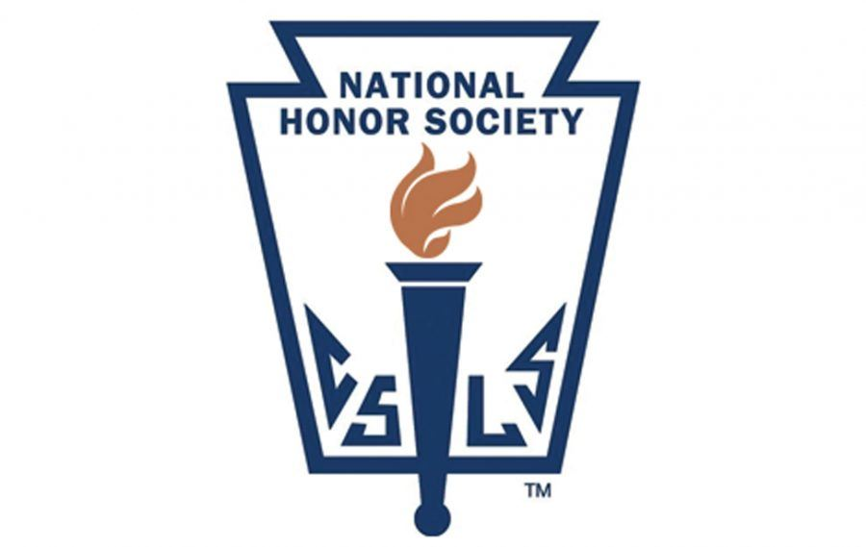
Dear Prospective Junior or Senior NHS Candidate:

Thank you for your interest in becoming a member of Central High School’s chapter of the National Honor Society. Membership in the National Honor Society (NHS) is one of the highest honors that can be awarded to a high school student. Our chapter has worked hard to bring the accomplishments of outstanding students to the attention of parents, teachers, peers, and the community. Our chapter strives to give practical meaning to the Society’s standards of scholarship, service, leadership, and character. These four ideals are considered as the basis for selection. No student is inducted simply because of a high academic average. The National Honor Society strives to recognize the total student—one who excels in all of these areas.

It is very important that you read the directions and timeline carefully before submitting your application to the NHS Advisor. This application document can be found on the NHS webpage on the Central High School website.
- go to the Central High School website
- click on Activities and Athletics drop down list
- choose Activities and click on National Honor Society in the dropdown menu
- click on the Central High School NHS link and choose Application on the right-hand side of the page

If you have questions e-mail them to sbarnhar@lacrossesd.org.

Sincerely,
Mrs. Suzanna Barnhart
NHS Adviser

2022-2023 Selection Timeline

September 9, 2022 Student application available online

September 30, 2022 Student applications due. Electronic submission through this form

October 2022 Adviser and Central Staff work to complete the following for all candidates:
- Faculty input surveys
- GPAs checked (3.30 minimum)
- Attendance checked.
- Faculty Committee meets for selection.
- Mr. Axness makes final decisions.

Early November 2022 Letters sent to all students to inform them of selection or non-selection.

November 14, 2022 NHS Induction Ceremony at 7:00 pm (Central High School Auditorium)

Criteria for Selection:

- Junior or Senior status.
- Must have demonstrated excellence in all of the following four areas:

Scholarship: A 3.30 or better cumulative GPA

Service: Involvement in service and volunteering for non-credit school and/or out-of-school activities.

Leadership: Demonstrated leadership in service, school, or work activities.

Character: Positive behavior implying adherences to the school conduct code as well as the law. This includes ethical behavior, cooperative relations with other students and staff, and integrity (no cheating, unexcused absences, intentional dishonesty, etc.).

- Each area above is reviewed independently.
- The Faculty Committee will determine whether you meet all four criteria by using GPA and attendance checks, a faculty and administration survey, and information provided on this application. Attaching appropriate references is also recommended.

- A simple majority of the Faculty Selection Committee is needed for approval.
- The final decision for selection will be made by Mr. Jeff Axness, Central High School Principal

- After students become members of the National Honor Society, they are reviewed periodically by the faculty and must maintain the high standards that were required for selection (including NHS approved service activities).

2022-2023 National Honor Society

Student Application

This application (only pages 4-7) is due to Mrs. Barnhart by September 30, 2022.

**Download this document in Microsoft Word and TYPE your responses**

Directions: Be sure to complete all sections. Completion of this application will include you in consideration for membership. It is not a guarantee of membership.

- Late applications will not be accepted.
- Must include both a student and parent/guardian signature.
- Any information supplied on this form should pertain to accomplishments during years in high school. Do not include information from 8th grade or earlier.
- Please be sure to accurately indicate organizational names, people, or titles.
- Recommendations by individual teachers at Central High School will not be accepted. All Central High School Faculty will have the chance to complete a faculty survey for those students turning in information sheets. Students are encouraged to have other adults in the community write letters of recommendation and attach them to this form. Letters should refer to the criteria used for selection.
- Fill out the Google form and upload pages 4-7 of this application as a word or pdf. attachment.
Name:
Mailing address:
Phone number:

Age: |  |  | Current Grade Level: |  | 11 |  |  | 12

Release: By signing or typing my name in this form, I grant permission to the National Honor Society, Circle Chapter advisor to gather and use all pertinent information from this form, school records, and any other relevant source in considering my selection. I will also accept the decision of the faculty committee charged with the responsibility of selecting members as final.

Candidate typed name & date:

I have read the information provided by my son/daughter on this form and can verify that it is true, accurate, and complete.

Print parent/guardian name & date:

Candidate Name:

- Co-curricular Activities- List all activities in which you have participated during high school. Include clubs, teams, musical groups, etc., and major accomplishments in each. DO NOT include classes taken for high school credits.

Activity | Year(s)  (Fr,So,Jr,Sr) | Accomplishments

- Leadership Positions- List all elected or appointed leadership positions held in school, community, or work activities. Only those positions in which you were directly responsible for directing or motivating others should be included. For example, elected student body, class, or club officers, committee chair-person, team captain, work area manager, or community leader.

Organization | Year(s)  (Fr,So,Jr,Sr) | Position

Candidate Name:

- Service Activities- List school or community service activities in which you have participated. These should be any activities in which you participated for the betterment of your school or greater community. Note any major accomplishment in each. Service activities are those which are done for, or on behalf of, others (not including immediate family members) for which no compensation to you or the group (monetary or other) has been given. Please list the name of an adult supervisor who can verify your participation in each activity.

Community Service  Activity  (in or out of school service) | Year(s)  (Fr,So,Jr,Sr) | Total  Hours | Major  Accomplishment(s) | Adult Sponsor name  & Phone # or email

Candidate Name:
- Work Experience, Recognition, and Awards – List below any job experiences, honors, or recognitions that you have received that support your bid to be selected for membership in the National Honor Society. Work experience may be paid or volunteer.

Job,  Recognition or  Award | Approx.  Dates | Group or Activity/  Number of Hours Spent on  Job or Volunteer Activity  (Hours/Week, Hours/Month, or Total Hours)

- This Section is Optional but Highly Recommended:

If there is anything else you would like the NHS Faculty Selection Committee to consider in addition to the information you have already provided, explain in the space provided. Type in this space, but do not go beyond the space provided.

- VI. This Section is Optional but Highly Recommended:
When you are ready to submit your application online using this form attach any letters of recommendations (non-Central H.S. Faculty) that will help in your pursuit to become a member of the NHS.

