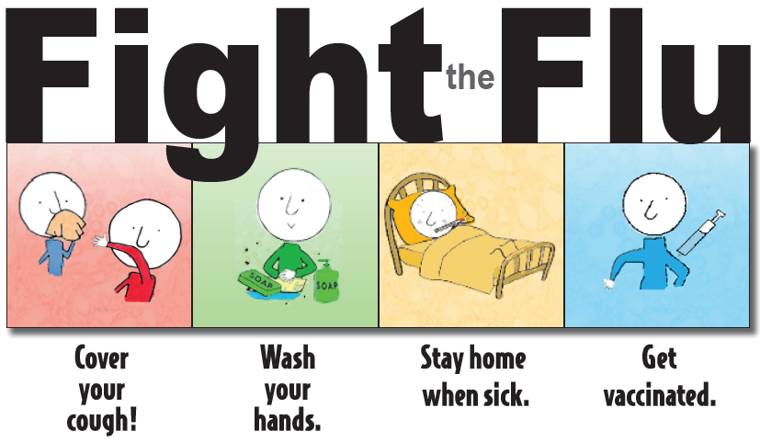

SAVE THE DATE:

Flu Clinics

No cost to family for children 6 months-18 years!

Does your child need their flu shot?

The La Crosse County Public Health Nurses will be holding three flu clinics on **Monday, October 15th, 2018**.

Clinic locations and times:

* **Longfellow Middle School in the LMC from 12-2 pm;**
* **Logan Middle School in the Office from 3-5 pm;**
* **Lincoln Middle School in the West Conference Room from 6-8 pm.**
* Flu shots for children (6 months thru 18 years old) provided at no cost to the family.
* Middle and high school age students may receive a flu shot at the clinic without a parent present if their “Vaccine School Consent Form for Middle and High Schoolers” is completed and signed by their parent or legal guardian.
* Elementary school age children must be accompanied by a parent or legal guardian.
* Influenza vaccine for adults age 19 and older will be available at the clinic on a fee for service basis with limited billable insurances. Call with questions.

The consent form, Vaccine Information Statements, and other vaccine related information can be found on the La Crosse County Health Department website at <http://www.lacrossecounty.org/health/docs/ForYourHealth/Immunization.pdf>. Click the link “Vaccine School Consent Form for Middle and High Schoolers” for consent form.

