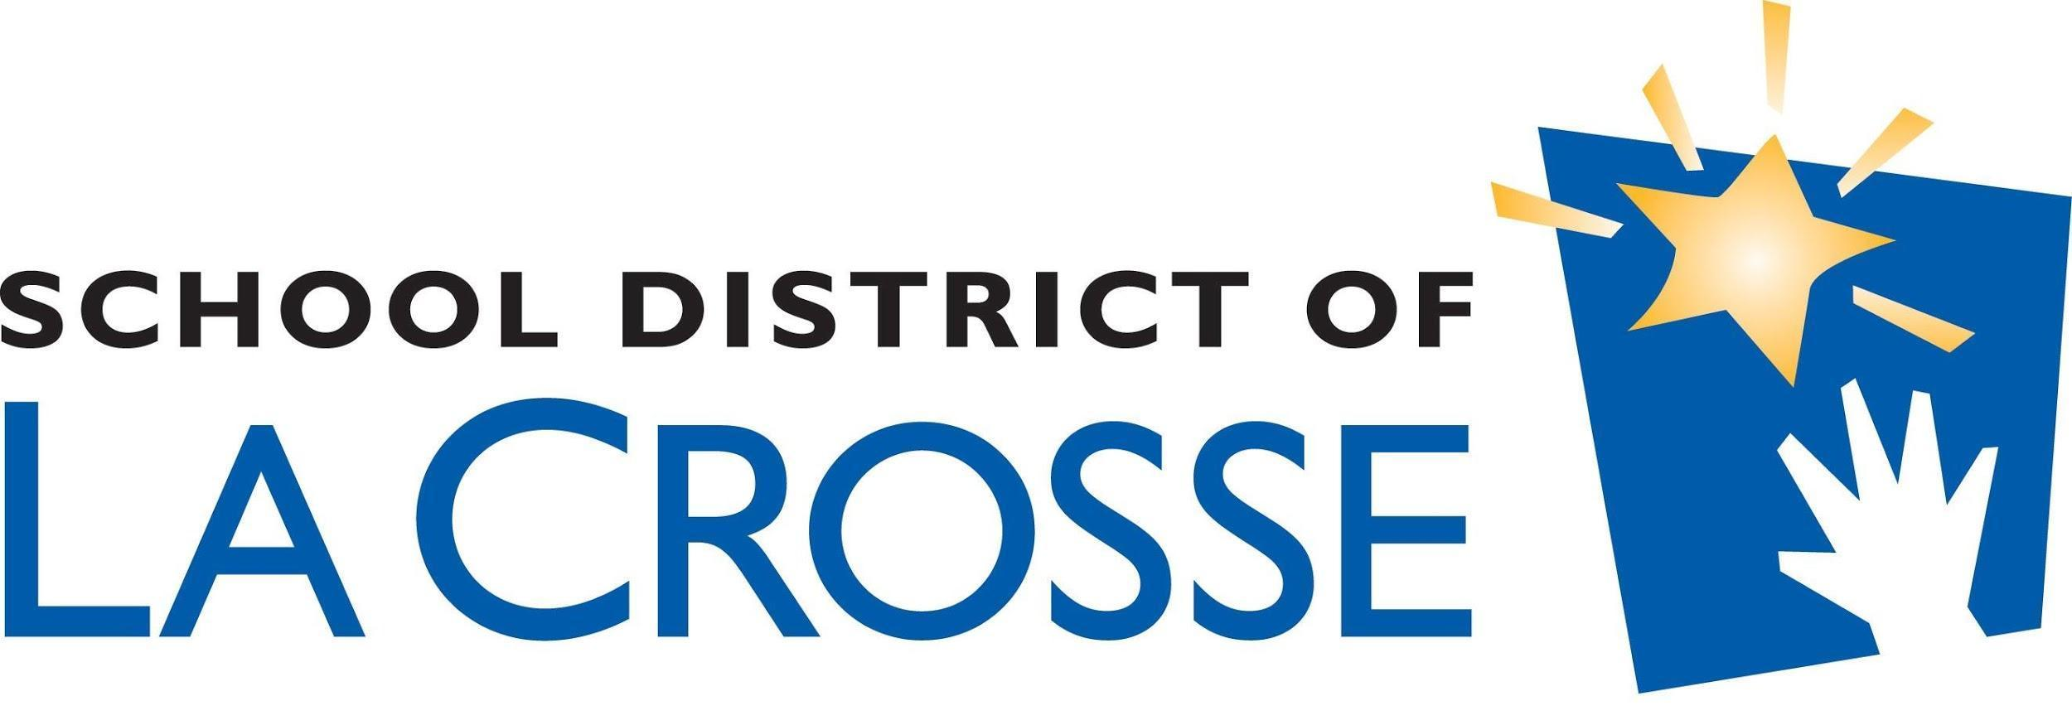

BLACK YOUTH SUMMIT 2020-21
PERMISSION SLIP
DATE: Saturday, March 13, 2021
TIME: 10:00 am – 2:00 p.m.
LOCATION: Lincoln Middle School via Zoom
Due to COVID The Black Youth Summit 2020-21 will be hosted via Zoom this year. We are requesting that transportation information is completed in case we are able to host the event in-person and students will need transportation.
Please fill out the information below if you would like your child to attend. Return the permission slip to your school Administrative Assistant or via email by Monday February 22, 2021:
Student’s Name: ______________________________________
Student’s School: ______________________________________
Grade: ______________________________________
Emergency Contact: ______________________________________
Emergency Contact Phone Number: __________________________
Adult Shirt Size: Small Medium Large X-Large
Will your child need a meal? Yes OR No Meat: Chicken Ham Vegan
Any health or allergy concerns: _______________________________________________________
Would your child need transportation for the event? Yes OR No
Please provide your address for student transportation and/or delivery Pick-up/ delivery address:___________________________________
Drop off address (if different from pick up) ________________________________________________________
Will your child need modifications and/or accommodations to attend this event: Yes OR No If “Yes” please specify: ________________________________________________________
Parent Signature:__________________________________________
Date: ___________________________________________________
DEADLINE TO TURN IN PERMISSION SLIP IS MONDAY FEBRUARY 22, 2021

Questions contact Ms. Day (office) 608.789.6620 or (email) dday@lacrossesd.org

