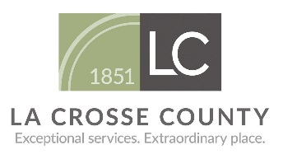
La Crosse County
Seal-A-Smile

A dental program provided in school and at no cost for students in 2nd and 3rd grades

- All you have to do is fill out the attached consent form and return it to your child’s teacher! All children who return the consent form will get a tooth brushing timer!
- Preventive dental services include: a basic screening, cleaning if needed, dental sealants, and fluoride varnish treatments.
- If your child has cavities, they will be referred to see a dentist. If your child does not have a dentist, a dentist may come to your child’s school to provide dental care. Restorative services include a dental exam, digital x-rays, composite (white) fillings, stainless steel crowns, and simple extractions.
Any student can receive dental services
through the school-based dental program.
(There are no eligibility or income requirements)

Dental services are provided through the La Crosse County Seal-A-Smile program by a Registered Dental Hygienist and a Licensed Dentist.

