Parent Newsletter
School of Technology & Arts I

Spring 2019 News
"Learning & Growing Together"

Dear Families,

The end of the year is fast approaching. With it comes warmer weather, longer days, lots of field trips, and special end-of-the-year events. I hope you can find a way to be present for these experiences to the extent that you're able.

I invite you to take a look at the many summer school offerings available in our district. These classes range in length from a few days to several weeks. These classes can help engage students in their interests and keeps their minds active.

We are fortunate in this community to have a variety of additional programs available to students. Please take a look at the offerings provided by: Park and Rec, YMCA, Boys and Girls Club, Pump House Regional Arts Center, and more. Many of these classes/activities fill up quickly, so make plans as soon as you can!

Yours in education, Mr. Burns

No School

April 18-22 – Spring Break

May 27 - Memorial Day

No Early Release

May 10 will be a full day of school.

Last Day of School

June 5
K-5 dismiss on June 5th at 11:56 am

Grade 5 Graduation Event
June 3rd at 2:15 p.m.

Upcoming Family Nights
Watch for the Registration Forms that will come home with your child

April 25 - Fancy Dance
May 9 - Bike Rodeo
May 29 - Informance @ Lincoln
May 30 - Family Math/Literacy Night

Health Room News
Greetings Hamilton/SOTA I families! Spring is finally here! With spring upon us, we have some helpful reminders to continue to keep our children and ourselves healthy.

Sleep - is your child getting enough?
The American Academy of Pediatrics recommends that children 3-5 years old should sleep 10-13 hours per 24 hours (including naps) on a regular basis. Children 6-12 years should sleep 9-12 hours per 24 hours and teenagers 13-18 years should sleep 8-10 hours per 24 hours! Not getting enough sleep each night can be associated with an increase in injuries, obesity, or high blood pressure compared to when you have adequate sleep on a regular basis; it can lead to improved behavior, learning, memory, and quality of life for all ages!

The AAP also recommends that all screens be turned off 30 minutes before bedtime and that all TV’s, computers or other screens not be allowed in the child’s bedroom. While that may seem like a hard thing to change, it is important to consider these recommendations and to at least try to find a compromise if you feel like your child isn’t getting enough sleep. A bedtime routine is crucial!

As always, the best preventative measures one can take to stay healthy are to wash hands often and thoroughly at any opportunity cover your coughs & sneezes -- and remind your children to do the same. Other helpful steps are: getting enough sleep, having a healthy breakfast, and limiting screen time as often as possible will help to keep your entire family healthy & happy!

Yours in health,
Amber Peters, Health Assistant & Michelle Rank, District Nurse

Youth Art Month

Youth Art Month Art Shows are upon us! Be sure to stop by both the north and south branches of the library to view art created by district students. Youth Art Month takes place each March, and at the end of March district schools select some pieces to be on display at the library.
Our pieces are on display from our school at the South Branch Library throughout April, and students with work displayed will receive a letter next week with more information. Also, be sure to like our Art Facebook Page at facebook.com/hamsotai

News from the Library

Joe C., Elliott L, Lucian K., and Camden D. tied for 19th in the state for this year's Battle of the Books competition. There were a total of of 218 elementary schools participating. The statewide Battle of the Books program is designed to promote a love of reading among our students. It encourages students to read a variety of books and remember information about the plots, characters, and settings of the books. Every question asked in a battle is answered by the title and author of the book. Way to go team "Library!"

Thank you for your support of our Scholastic Book Fair. Our book fair came and went quickly, but the impact you made on kids will continue as long as we keep providing them access to fresh, new books. We sold $1400 dollars in merchandise. This earned our school $570 in Scholastic Dollars. We used this money to purchase books 50 books from the Scholastic Book Fair.

All materials will be due to the Hamilton/SOTA I Library by end of the day on May 24th. At that time the library will complete their annual inventory of the 12,000 materials found in the library. Thank you for the support of the library and returning all items.

Save the Date: HPL and Drum Circle Open House on Thursday, May 16th from 4:30-6:30 PM. Ms, Wakeen and Mrs. Harden welcome you to come and celebrate the accomplishments of our friends in HPL (High Performance Learning) and members of the Hamilton/SOTA I Drum Circle at our second open house. Our school rocks!

Farm to School Survey

Parents and Caregivers, thank you in advance for taking time to complete this important survey about nutrition, health and Farm2School at your child(ren)'s school(s). Your responses will provide helpful feedback to help us make improvements for next year's programming.
https://www.surveymonkey.com/r/parentf2s
Participants have a chance to win one of 6 farmer’s market gift cards just for taking the survey. Good Luck. Thank you for your participation in helping us grow our program.

211 Services
Know that help is available if you don’t know where to turn for child/youth mental health or substance abuse resources. Dial 211 for free and confidential:
- Crisis line services
- Community information
- Provider information (names, hours, specialties, payment options, etc.)
- Support Groups
- And more…

Grow Garden News

Grow La Crosse will be providing garden education at Hamilton & SOTA I this year. The lessons will be:

- Health Soil - Doing a soil and compost study and learn how health soil benefits the plants.
- Health Mind - Taking a look at “caring work” (actions based on empathy, responsibility and concern) that can be done in the garden and learn about plant growth and ecosystems.
- Healthy Body - Exploring how health food is essential for a health body. Then doing a taste test of spinach alone as well as in a Green Goodness smoothie.

If you would like to volunteer, contact linda@growlacrosse.org to get more details.

Safe Routes to School Walks Resume

Reminder that kids and parents meet at Powell Park at 7:40 a.m. each Wednesday to walk to school. The walk starts at 7:45 a.m. We walk rain or shine, but walks will be cancelled if there is thunder or lightning. If you have questions or concerns, contact our Safe Routes to School Parent Liaisons: Erika Cedergren at 513-417-6923 and Doris Faucheux at 360-790-1478.

*** Times, dates and locations are subject to change ***
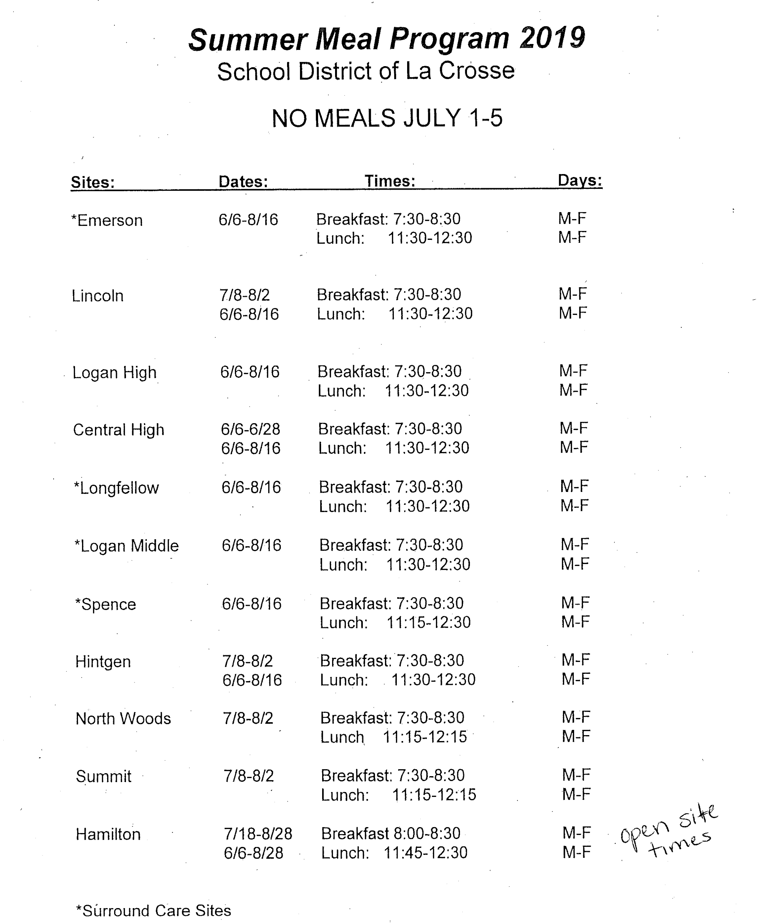

Summer School 2019 Online Registration is now open at:
www.lacrosseschools.org/programs-services/summer-school
Deadline is April 17th.
For questions, cal 789-8955 or e-mail summer@lacrossesd.org

