SOTA 1 expense reimbursement.

PROCEDURE:
- Get approval from steering committee
- Save the receipts when you buy stuff.
- Email the treasurer SOTA1treasurer@gmail.com. Include the following information:
  - Name and address to send the reimbursement check
  - Description of what was purchased
  - Receipt image - a picture from a cell phone camera is fine.
- Treasurer will send reimbursement payment through “BillPay” at Marine Credit Union.
  - Billpay is a physical check sent from Marine Credit union to the recipient.

EXAMPLE EMAIL:

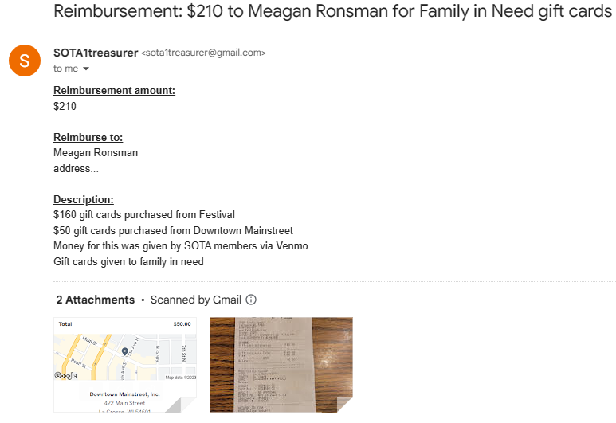
Subject:

